Human Biology – ATAR Year 12
Unit 3 Science Investigating Skills Task 1
Investigation – Temperature regulation mechanisms of the human body (50 Marks)

The AFL football season now starts in February and finishes late September. When games are played on hot summer days early in the season, players coming off the field are often seen resting on the bench wearing an ice jacket or standing in front of large fans.
These infrared digital images show the effect of wearing the ice jacket.
A B C
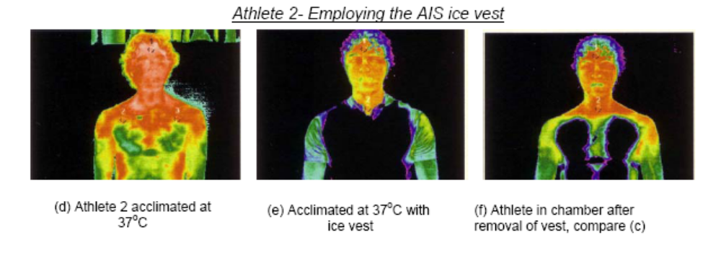
hot areas
cold areas
From: http://www.dest.gov.au/NR/rdonlyres/45859B13-3E95-43E0-B383-7742447A1B6B/2001/STinSportReport.pdf

A: Player showing heat distribution immediately after coming off the ground.
B: Player when wearing the ice jacket.
C: Player immediately after removing the ice jacket.

- What is the main method of heat lost from the skin when:

  - wearing the ice jacket? _________________________________(1 Mark)
  - standing in front of the fan?________________________________(1 Mark)
- Players standing in front of the fan returned to normal temperature faster than those wearing the ice jackets.
Explain this observation.

__________________________________________________________________
__________________________________________________________________
____________________________________________________________________________________________________________________________________
(2 marks)

- Is the use of ice jackets to be recommended for reducing the body temperature of athletes? Explain why or why not?
______________________________________________________________________________________________________________________________________________________________________________________________________
(1 Marks)

Assessment Type : Science Inquiry

You are required to plan, conduct and evaluate an investigation based on the temperature regulation mechanisms of the human body. You will write up your investigation as a scientific report.

Conditions:

Time allowed for completion of the task:
• investigation planning – one class period
• conduction of investigation – up to three class periods
• completion of the introduction, materials and method sections of the scientific report – at home
• completion of the results, analysis and evaluation of data sections of the scientific report – one period under test conditions

Task weighting
2.5% of the school mark for this pair of units

Plan the investigation
Things to consider when planning your investigation:
• research and provide background information on temperature regulation mechanisms
• devise an hypothesis and choose dependent and independent variables for your investigation
• identify variables to control
• decide upon the appropriate sample size, trials and data collection methods
• describe, in detail, the methodology you will use during your investigation
• decide upon the data recording method.
Conduct the investigation
• set up times and places for the measurements to be taken
• carry out data collection from test subjects
Commence writing the scientific report (10 marks)
• include an introduction to the investigation
• include the background research on temperature regulation mechanisms
• write the hypothesis for the investigation
• identify the dependent and independent variables

Materials and method (6 marks)
• include a list of materials used in the investigation
• include details on the method used to collect the data
• include design features of the investigation that ensured reliability and validity
Complete the remainder of the scientific report under test conditions.
Results (11 marks)
• show processing of raw data by identifying any outliers and working out averages
• plot appropriate graphs by hand to show results
Analysis and evaluation (14 marks)
• describe the trend and/or pattern in your data
• state how your data relates to your hypothesis
• use your knowledge and understanding to explain the trend and/or pattern of your results
• comment on the reliability and accuracy of the data collected
• list two limitations in the data collection strategy that may have affected the reliability of your data and comment on how they would have affected it
• list two improvements you could make to the data collection strategy to improve your investigation
Conclusion (4 marks)
• summarise your findings and comment on the reliability and validity of the outcome of the investigation

Marking key - Unit 3 SIS 1
Commence writing the scientific report.
• include an introduction to the investigation
• include the background research on temperature regulation mechanisms
• write the hypothesis for the investigation
• identify the dependent and independent variables
Description | Mark
Succinctly writes a general introduction that summarises the aim of the investigation | 1
Provides background information on temperature control mechanisms and the function of the following in maintaining constant body temperature:  • vasoconstriction/vasodilation  • shivering  • piloerection  • sweating  • importance of maintaining constant body temperature, optimal for reactions | 1  1  1  1  1
Writes a hypothesis relating dependent and independent variables and stating direction of effect  OR  Writes a simple hypothesis relating dependent and independent variables without stating direction of effect | 2  1
Correctly identifies the dependent and independent variables | 1–2
Total | 10

